Version 1.0.0

29th December 2017

Capgemini Immediate

Bank of Ireland CBSP Programme – Temenos 16.12 Packer Terraform Process

Table of Contents

[1 Introduction 2](#_Toc502634259)

[1.1 Packer 2](#_Toc502634260)

[1.2 Terraform 2](#_Toc502634261)

[1.3 GoCD Screenshots of Packer & Terraform Pipelines 3](#_Toc502634262)

[2 Document Control 10](#_Toc502634263)

# Introduction

This document can be used as the knowledge base for the packaging and provisioning of Temenos 16.12 application on Linux environment for BOI using packer and terraform tools.

Since we are looking to create single image (common for all environment)Temenos aio server image, Temenos app server, Temenos Browser web server, Temenos TCIB server Images for all the environment, we are running puppet during packer process and running the user data scripts at during terraform process. DB specific details will be run during the Terraform process through user-data.

Our Temenos puppet script is developed considering that certain steps are executed during packer process which is not specific to any environments and the rest of the steps will be executed during the terraform process by feeding the environment specific details. We use pipeline’s “Environmental Variables” to feed the details to puppet.

We have explained the variables and the values that needs to be feed to the pipeline as input to puppet.

## Packer

Packer is easy to use and automates the creation of any type of machine image. It embraces modern configuration management by encouraging you to use automated scripts to install and configure the software within your Packer-made images. We use puppet automated scripts to build image. Instead of doing this activity from command line of Linux, we use a tool called GoCD where we create pipelines to do this process.

“D1\_environment” is the GoCD Environment where the pipeline “[Temenos\_aio\_server](https://infra.omegatooling.com/go/admin/pipelines/activid_aio_server/general)” belongs to. This pipeline is used to create AMI image for Temenos application using packer tool. We have created this pipeline in GoCD where we need to feed information and build image.

## Terraform

Terraform is a tool for building, changing, and versioning infrastructure safely and efficiently. Terraform can manage existing and popular service providers as well as custom in-house solutions.

“D1\_environment” is the GoCD Environment where the pipeline “[D1\_Temenos\_aio\_provisioner](https://infra.omegatooling.com/go/admin/pipelines/D1_activid_aio_provisioner/general)” belongs to. This pipeline is used to provision Temenos aio server using terraform tool. User-data execution after provisioning using Terraform. As usual those details will be feed through Environmental variables of Pipeline.

Four stages of Terraform

* Plan

Plan the provisioning, this stage gives the list of resources that will gets provisioned during apply stage

* Apply

Provision all the resources that was planned during previous stage

* Plan\_Destroy

Plan for destruction of resources

* Destroy

Actual destroy

All of the above stages will be defined in a single template

<https://infra.omegatooling.com/go/admin/templates/RADEV1_ENV_temenos_aio/general>

User Data

*User data* is a blob of data that the user can specify when they launch an instance. The instance can access this data through the metadata service or config drive. Commonly used to pass a shell script that the instance runs on boot.

For example, one application that uses user data is the [cloud-init](https://help.ubuntu.com/community/CloudInit) system, which is an open-source package from Ubuntu that is available on various Linux distributions and which handles early initialization of a cloud instance.

Below is the order of user data scripts that gets executed just after server provisioning

* rhel\_host\_setup

Sets hostname of the server as per the TEMENOS\_HOSTNAME Environment variable of the provisioner pipeline

* rhel\_banking\_extra\_volume\_mount

Use LVM to partition the extra volume and mount it in /data directory

* rhel\_banking\_host\_entries\_db

Add the host entries of db server to /etc/hosts file

* rhel\_activid\_jboss\_puppet\_exports\_user\_data

Exports the environment specific details to facter variables

* rhel\_temenos\_user\_data

Execute the userdata for temenos aio appilcations

* rhel\_temenos\_log\_location\_update

Update the server.log location to point to /data directory and restart the activid service

## GoCD Screenshots of Packer & Terraform Pipelines

GoCD Environment



<https://infra.omegatooling.com/go/environments/D1_environment/show>

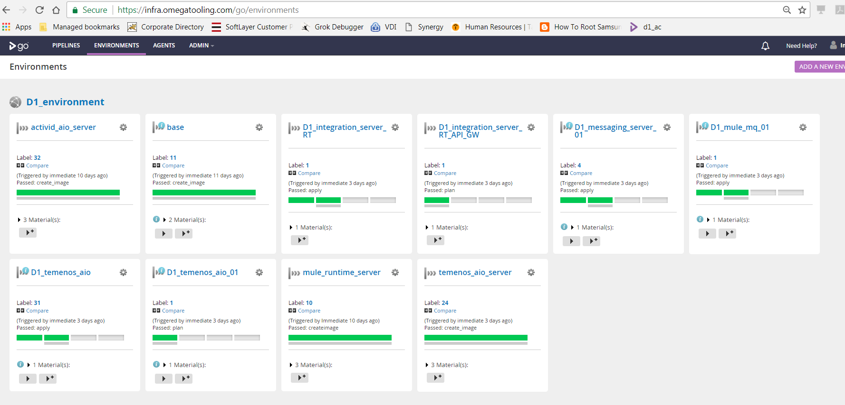

Packer – Image Builder Pipeline

Temenos\_aio\_server:

<https://infra.omegatooling.com/go/admin/pipelines/temenos_aio_server/general>

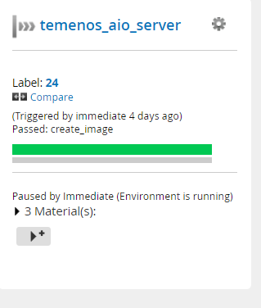

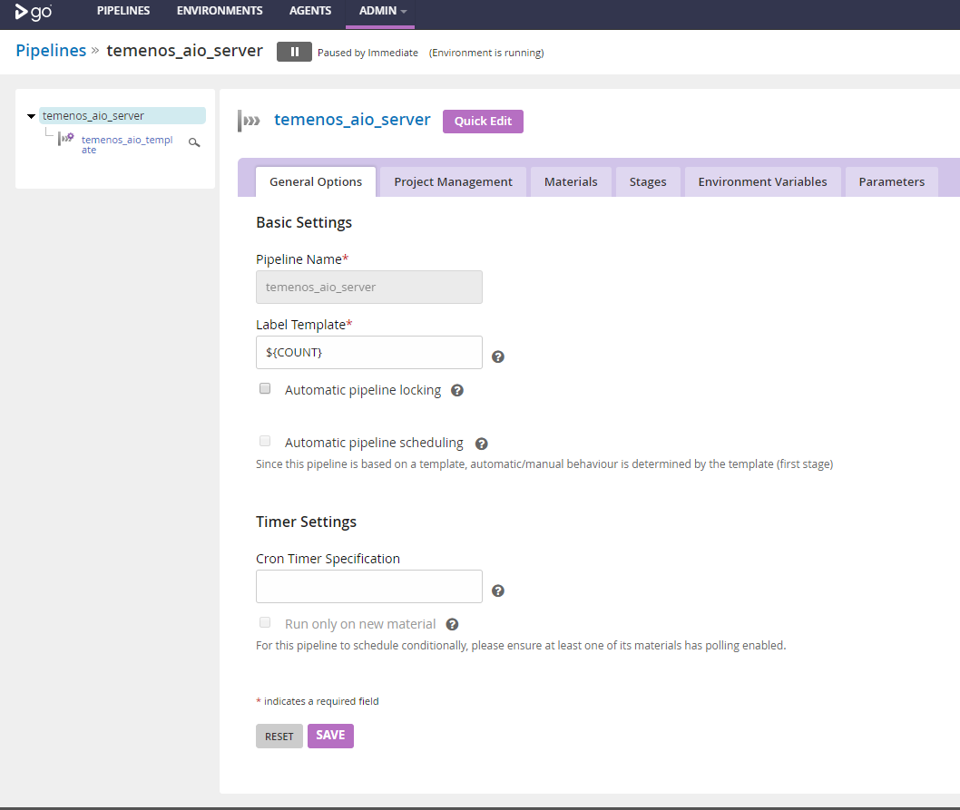

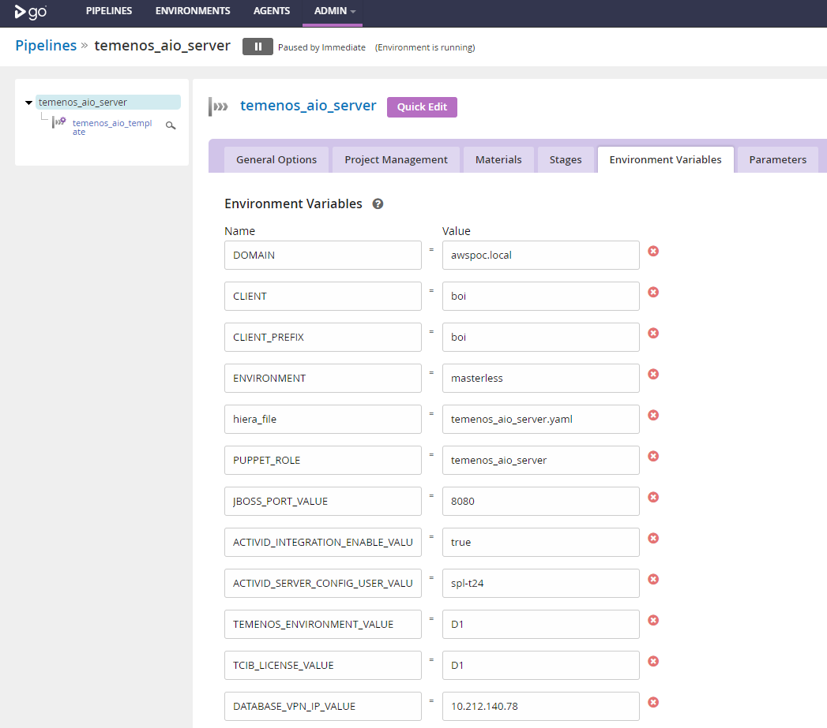 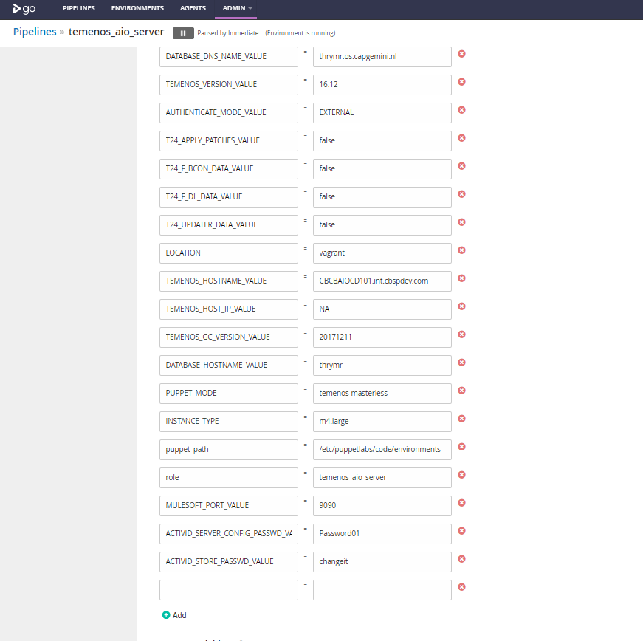

* JBOSS\_PORT\_VALUE
  + Setting the jboss port value to deploy the temeons application.
* ACTIVID\_INTEGRATION\_ENABLE\_VALUE
  + If it is true then it will integrate with hid else temenos use the internal authentication module to authorize the user.
* ACTIVID\_SERVER\_CONFIG\_USER\_VALUE,ACTIVID\_SERVER\_CONFIG\_PASSWD\_VALUE
  + Providing username password temenos-hid integration
* TEMENOS\_ENVIRONMENT\_VALUE
  + Setting the temenos\_environment for deploying the browserweb
* TCIB\_LICENSE\_VALUE
  + Tcib\_license will be downloaded from the nexus based on the vaule provided.
* TEMENOS\_VERSION\_VALUE
  + Temenos\_version deploying version details.

* AUTHENTICATE\_MODE\_VALUE
  + Based on the value authentication mode will set. (INTERNAL/EXTERNAL).
* T24\_APPLY\_BATCHES,T24\_F\_DL\_DATA,T24\_B\_CON\_DATA,T24\_UPDATER\_DATA
  + This variables for Patch updates. If it is true it will update the patches.
* DATABASE\_VPN\_IP,DATABASE\_DNS\_NAME\_VAULE,DATABASE\_HOST\_NAME\_VALUE,TEMENOS HOSTNAME,TEMENOS\_HOSTIP
  + For making Local entry in /etc/hosts
* TEMENOS\_GC\_VERSION\_VAULE
  + Golden Copy version to deploy in servers.
* MULESOFT\_PORT\_VALUE
  + Mulesoft port value for integration between temenos and mule

All of the above parameters are mandatory for puppet run during packer process of temenos aio server .

**Temenos Clustering**

We have implemented Temenos in clustering mode in PREPROUD environment and Created the environment banking images for packer process.

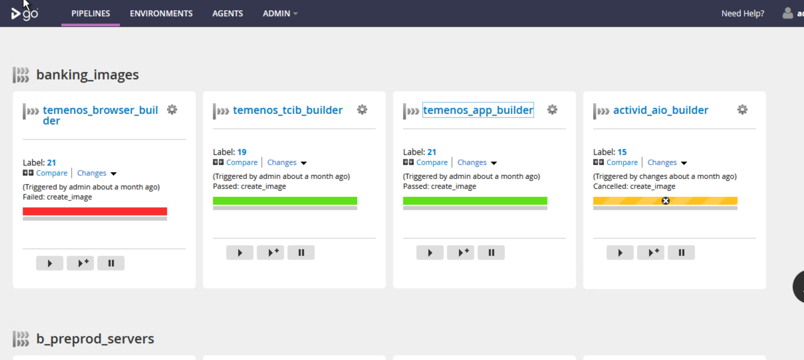

**Temenos\_App\_builder**

We are building the temenos\_app\_server image by using this pipeline. This image will be used for provisioning the temenos\_app\_hc\_server, temenos\_app\_dc\_server.

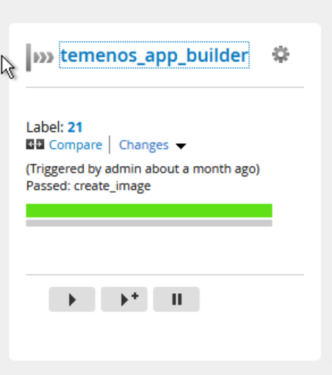

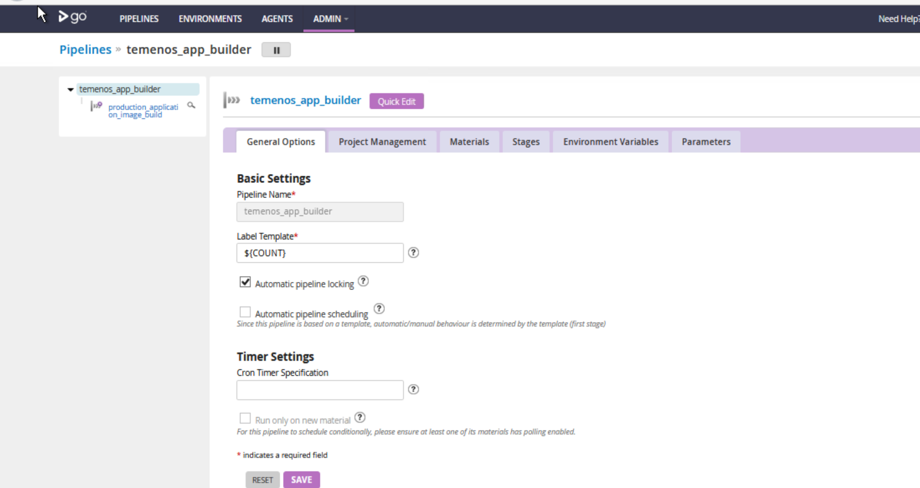

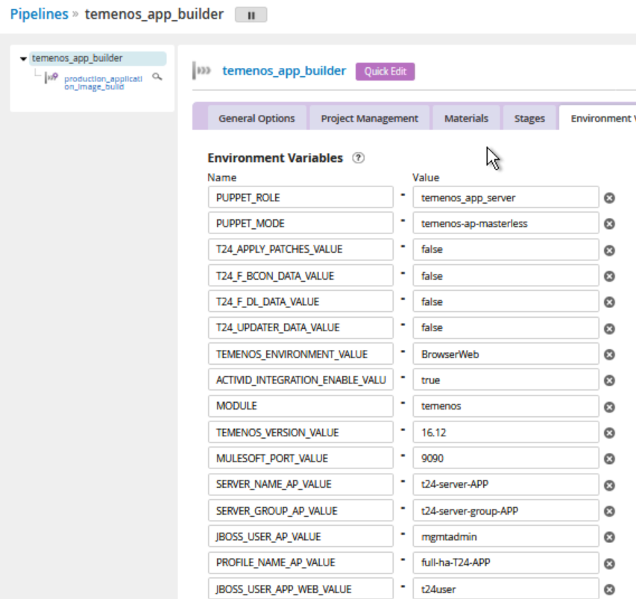 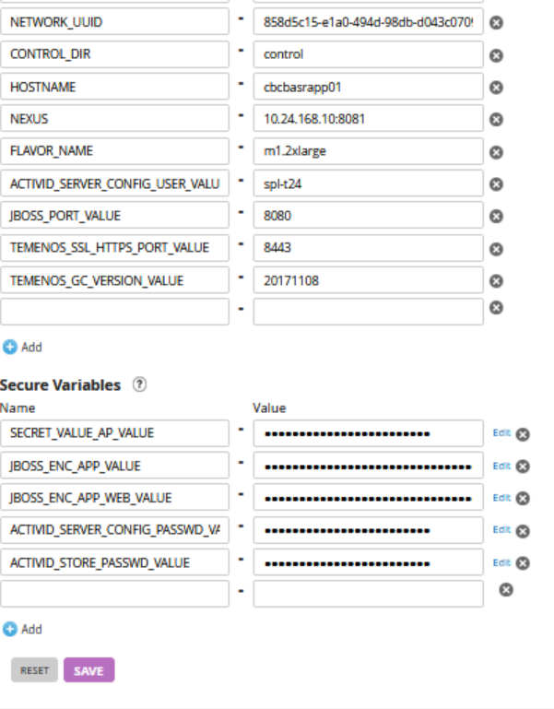

* JBOSS\_PORT\_VALUE
  + Setting the jboss port value to deploy the temeons application.
* ACTIVID\_INTEGRATION\_ENABLE\_VALUE
  + If it is true then it will integrate with hid else temenos use the internal authentication module to authorize the user.
* ACTIVID\_SERVER\_CONFIG\_USER\_VALUE,ACTIVID\_SERVER\_CONFIG\_PASSWD\_VALUE
  + Providing username password temenos-hid integration
* TEMENOS\_ENVIRONMENT\_VALUE
  + Setting the temenos\_environment for deploying the browserweb
* TEMENOS\_VERSION\_VALUE
  + Temenos\_version deploying version details.
* T24\_APPLY\_BATCHES,T24\_F\_DL\_DATA,T24\_B\_CON\_DATA,T24\_UPDATER\_DATA
  + This variables for Patch updates. If it is true it will update the patches.
* TEMENOS\_GC\_VERSION\_VAULE
  + Golden Copy version to deploy in servers.
* MULESOFT\_PORT\_VALUE
  + Mulesoft port value for integration between temenos and mule
* SERVER\_NAME\_AP\_VALUE
  + Temenos application server name in clustering
* SERVER\_NAME\_GROUP\_VALUE
  + Temenos application server’s group name will be created based on the variable input.
* JBOSS\_USER\_AP\_VAULE
  + Management user for jboss clustering
* PROFILE\_NAME\_AP\_VALUE
  + Profile name of the temenos clustering will be passed into the domain.xml.
* JBOSS\_USER\_APP\_WEB\_VAULE
  + Application user for communication between app and web server.
* TEMENOS\_SSL\_HTTPS\_PORT\_VALUE
  + Temenos application will be deployed on this port
* SECRET\_VALUE\_AP\_VAULE
  + Value will be used in host-slave.xml for clustering related configuration
* JBOSS\_ENC\_APP\_VALUE
  + Encrypted value for management user for jboss clustering
* JBOSS\_ENC\_APP\_WEB\_VAULE
  + Encrypted value for Application users will be upadted
* ACTIVID\_STORE\_PASSWD\_VALUE
  + This variable will be used in the hid configuration configuration file.

**Temenos\_browser\_builder**

We are building the temenos\_app\_server image by using this pipeline. This image will be used for provisioning the temenos\_browser\_hc\_server, temenos\_browser\_dc\_server.

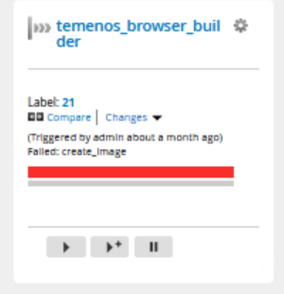

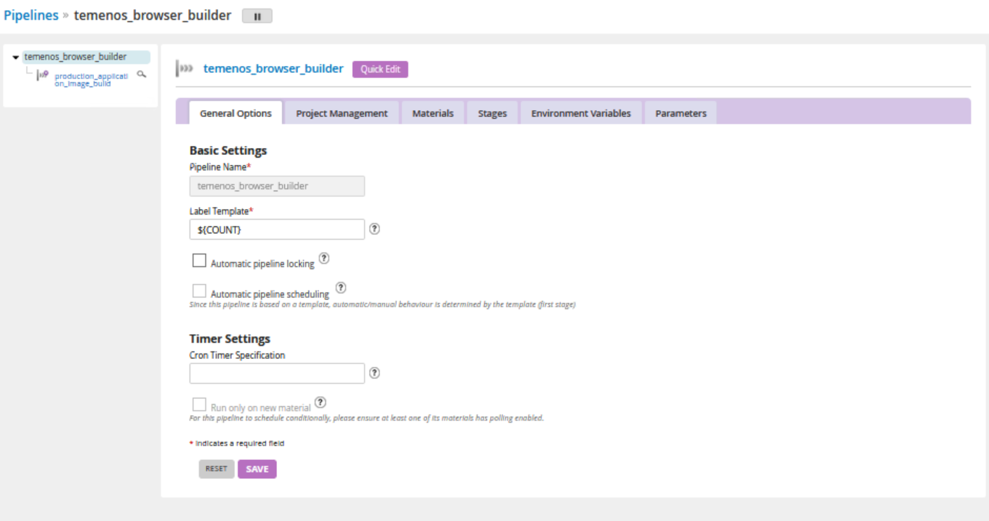

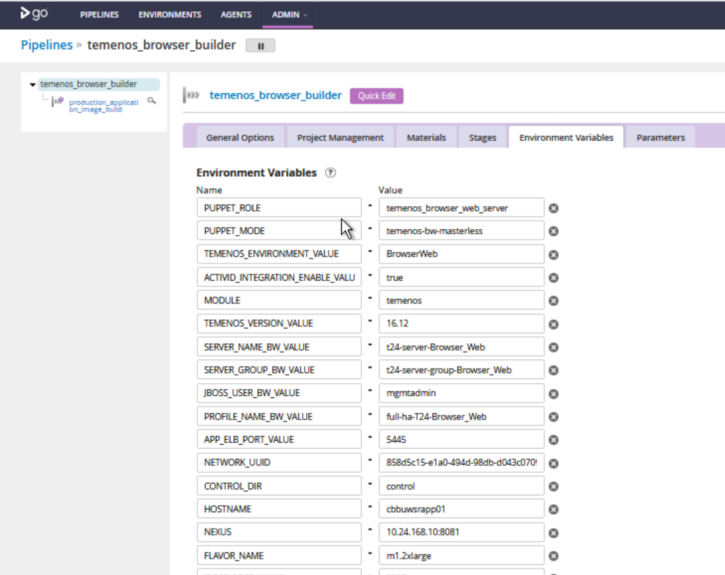

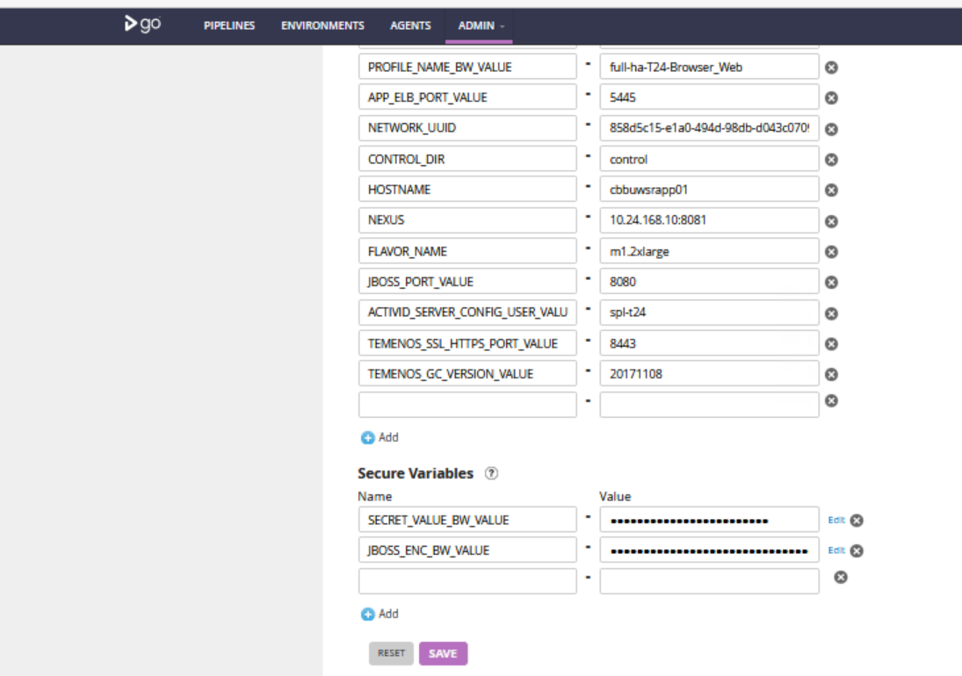

* JBOSS\_PORT\_VALUE
  + Setting the jboss port value to deploy the temeons application.
* ACTIVID\_INTEGRATION\_ENABLE\_VALUE
  + If it is true then it will integrate with hid else temenos use the internal authentication module to authorize the user.
* ACTIVID\_SERVER\_CONFIG\_USER\_VALUE
  + Providing username temenos-hid integration
* TEMENOS\_ENVIRONMENT\_VALUE
  + Setting the temenos\_environment for deploying the browserweb
* TEMENOS\_VERSION\_VALUE
  + Temenos\_version deploying version details.
* TEMENOS\_GC\_VERSION\_VAULE
  + Golden Copy version to deploy in servers.
* MULESOFT\_PORT\_VALUE
  + Mulesoft port value for integration between temenos and mule
* SERVER\_NAME\_BW\_VALUE
  + Temenos Browserweb server name in clustering
* SERVER\_NAME\_BW\_GROUP\_VALUE
  + Temenos Browserweb servers group name will be created based on the variable input.
* JBOSS\_USER\_BW\_VAULE
  + Management user for jboss clustering
* PROFILE\_NAME\_BW\_VALUE
  + Profile name of the temenos clustering will be passed into the domain.xml.
* TEMENOS\_SSL\_HTTPS\_PORT\_VALUE
  + Temenos application will be deployed on this port
* SECRET\_VALUE\_BW\_VAULE
  + Value will be used in host-slave.xml for clustering related configuration
* JBOSS\_ENC\_BW\_VALUE
  + Encrypted value for management user for jboss clustering
* APP\_ELB\_PORT\_VALUE
  + Load balancer port no for communicating the APP Server

**Temenos\_tcib\_builder**

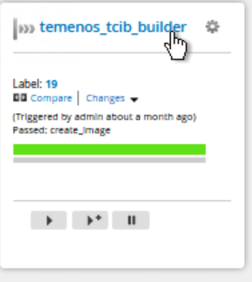

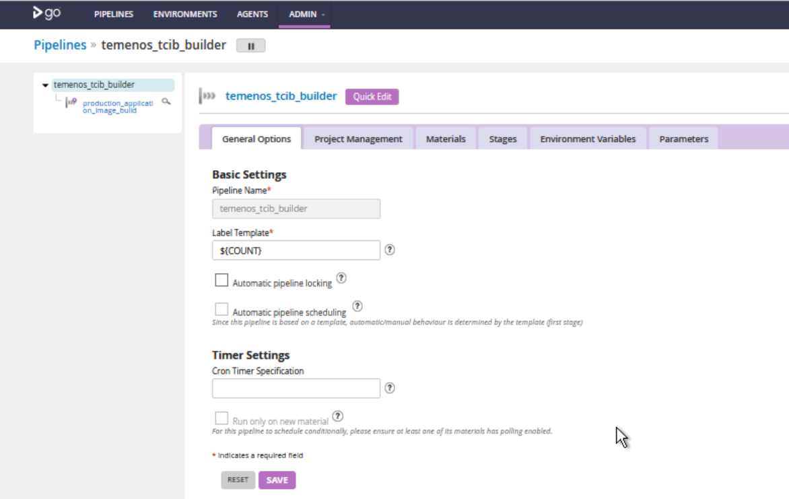

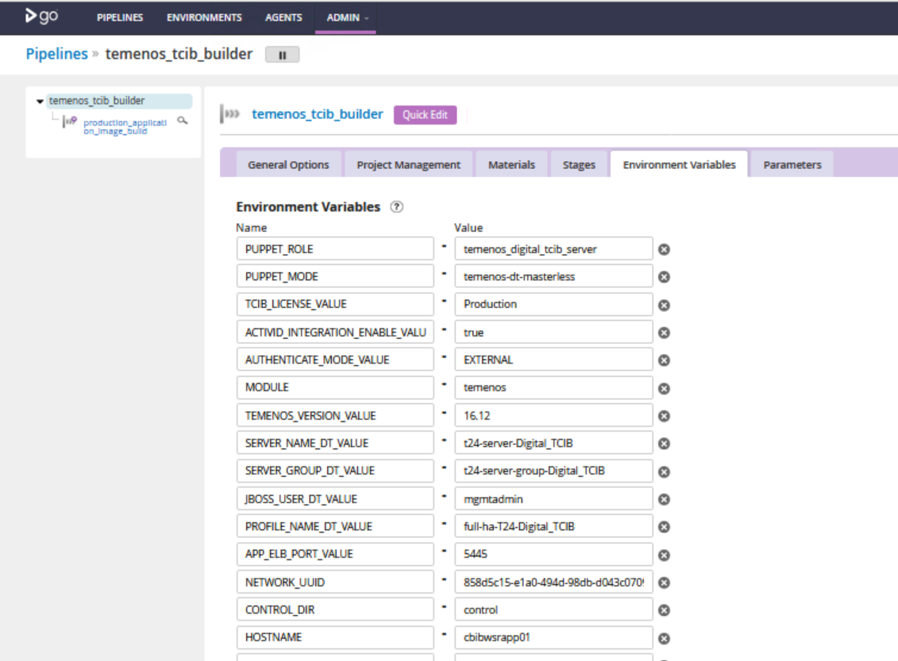

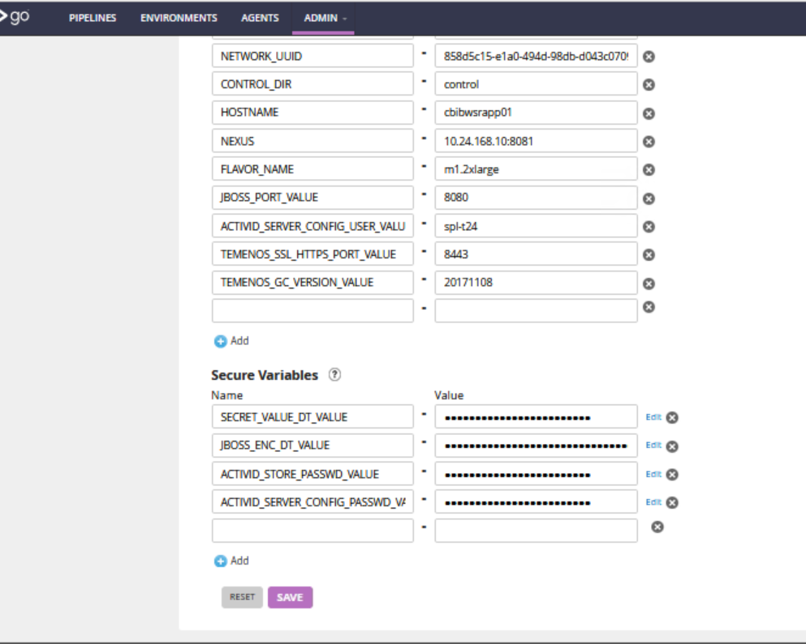

* JBOSS\_PORT\_VALUE
  + Setting the jboss port value to deploy the temeons application.
* ACTIVID\_INTEGRATION\_ENABLE\_VALUE
  + If it is true then it will integrate with hid else temenos use the internal authentication module to authorize the user.
* ACTIVID\_SERVER\_CONFIG\_USER\_VALUE,ACTIVID\_SERVER\_CONFIG\_PASSWD\_VALUE
  + Providing username password temenos-hid integration
* TEMENOS\_VERSION\_VALUE
  + Temenos\_version deploying version details.
* TEMENOS\_GC\_VERSION\_VAULE
  + Golden Copy version to deploy in servers.
* MULESOFT\_PORT\_VALUE
  + Mulesoft port value for integration between temenos and mule.
* SERVER\_NAME\_DT\_VALUE
  + Temenos digital server name in clustering
* SERVER\_NAME\_GROUP\_DT\_VALUE
  + Temenos digital server’s group name will be created based on the variable input.
* JBOSS\_USER\_DT\_VAULE
  + Management user for jboss clustering
* PROFILE\_NAME\_DT\_VALUE
  + Profile name of the temenos clustering will be passed into the domain.xml.
* TEMENOS\_SSL\_HTTPS\_PORT\_VALUE
  + Temenos application will be deployed on this port
* SECRET\_VALUE\_DT\_VAULE
  + Value will be used in host-slave.xml for clustering related configuration
* JBOSS\_ENC\_DT\_VALUE
  + Encrypted value for management user for jboss clustering
* ACTIVID\_STORE\_PASSWD\_VALUE
  + This variable will be used in the hid configuration file.
* APP\_ELB\_PORT\_VALUE
  + Load balancer port no for communicating the APP Server

Terraform – Server Provisioner Pipeline

<https://infra.omegatooling.com/go/admin/pipelines/D1_temenos_aio/general>

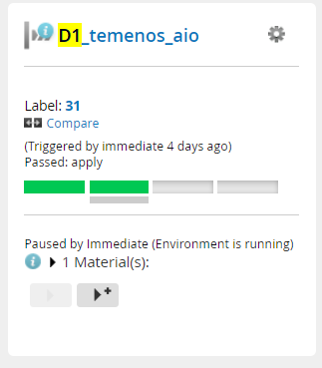

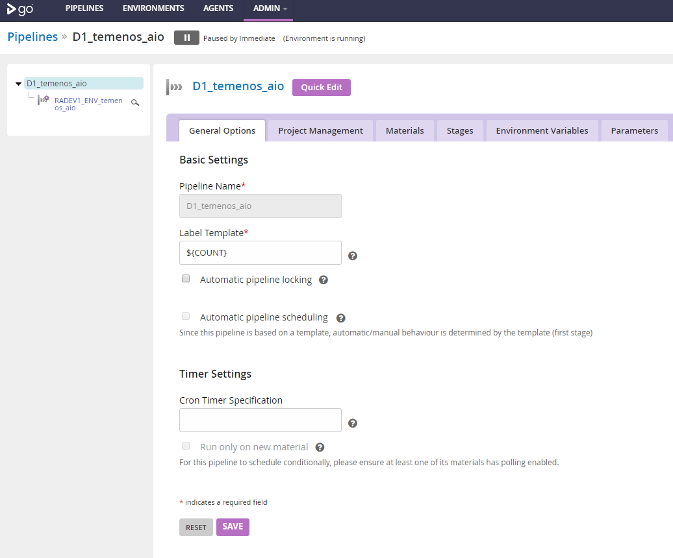

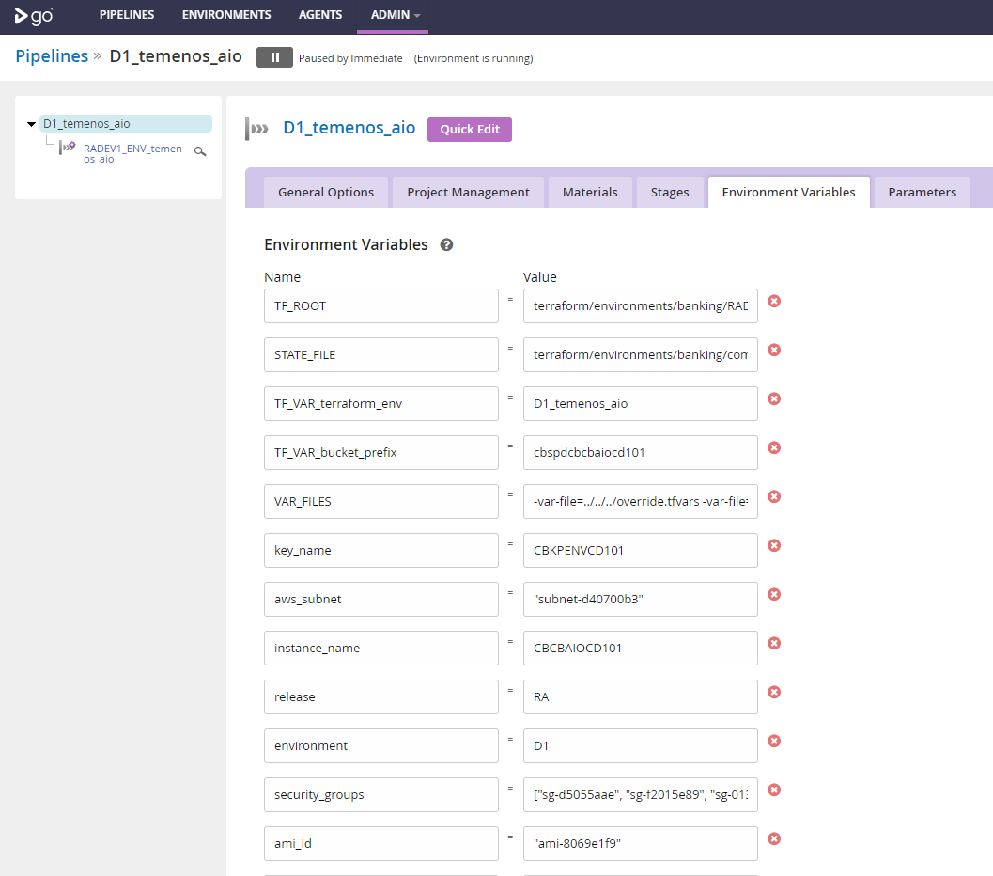

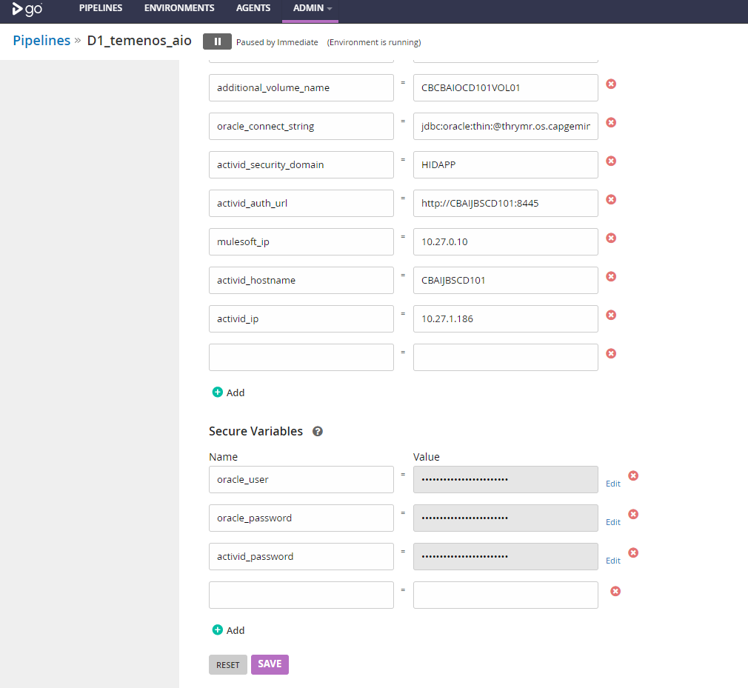

* ACTIVID\_HOSTNAME = <activid\_hostname>
  + Hostname for the provisioned server – permanent
* ACTIVID\_IP = <activid\_ip>
  + ip of the activid machine.
* ACTIVID\_AUTH\_URL
  + Activid url
* Mulesoft\_ip
  + Ip of the mulesoft server
* ORACLE\_CONNECTION\_STRING = jdbc:oracle:thin:@<db\_hostname>:<db\_port>:<db\_sid>
  + Jdbc url used to connect with database

or provisioning Temenos aio application for any new environment, we just have to clone this pipeline and update the environment specific details and trigger the pipeline.

Temenos Clustering

In Preprod environment we have created the b\_preprod\_servers for temenos clustering. In Clustering we are having the host controller server provisioner pipelines, domain controller server provisoner pipelines created for app, browser web, tcib components.

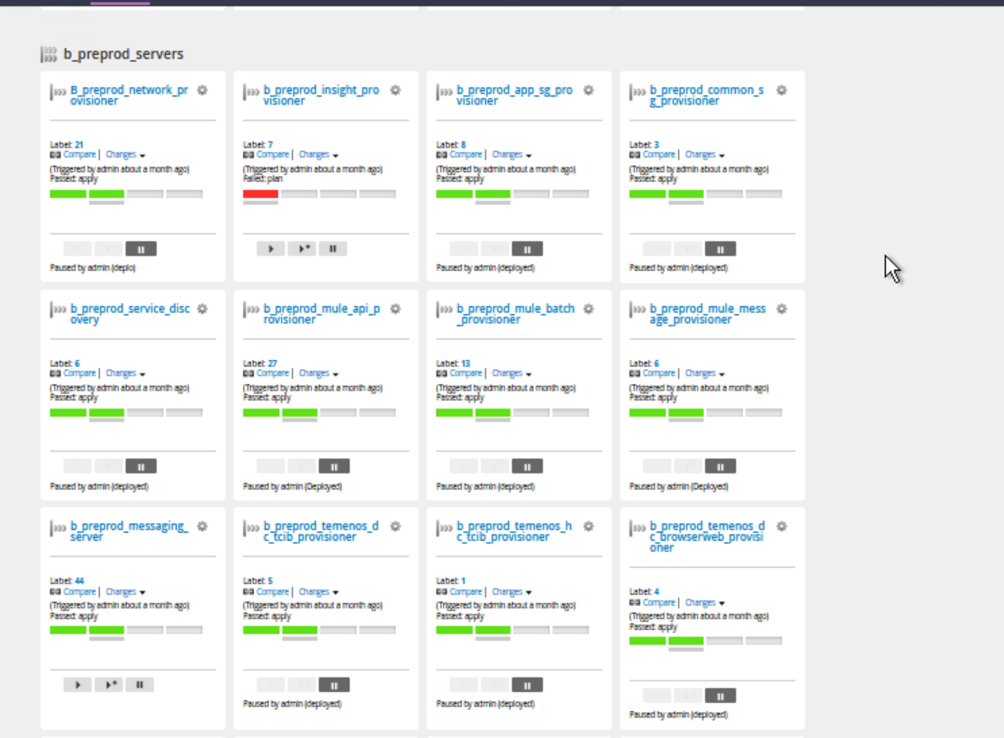

b\_preprod\_temenos\_dc\_tcib\_provisioner

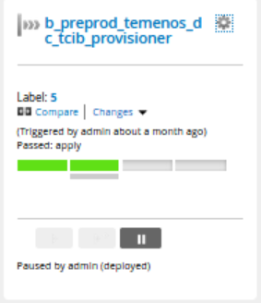

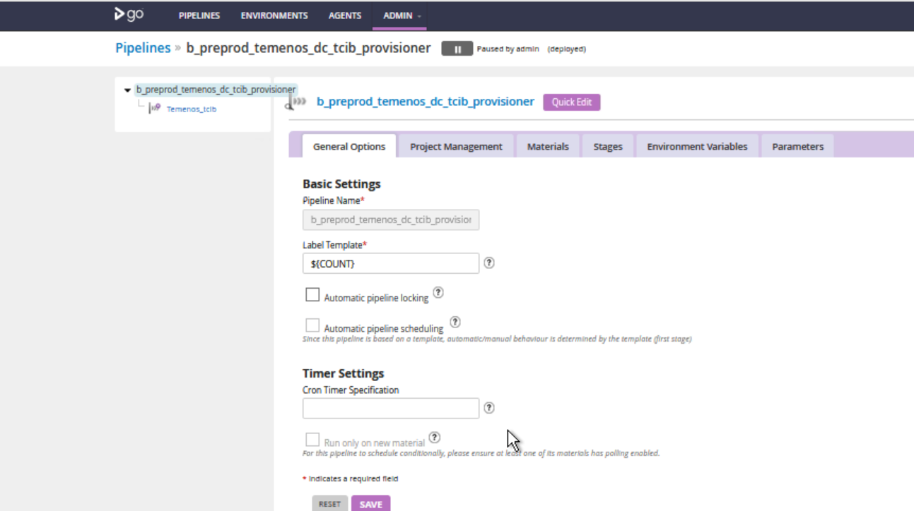

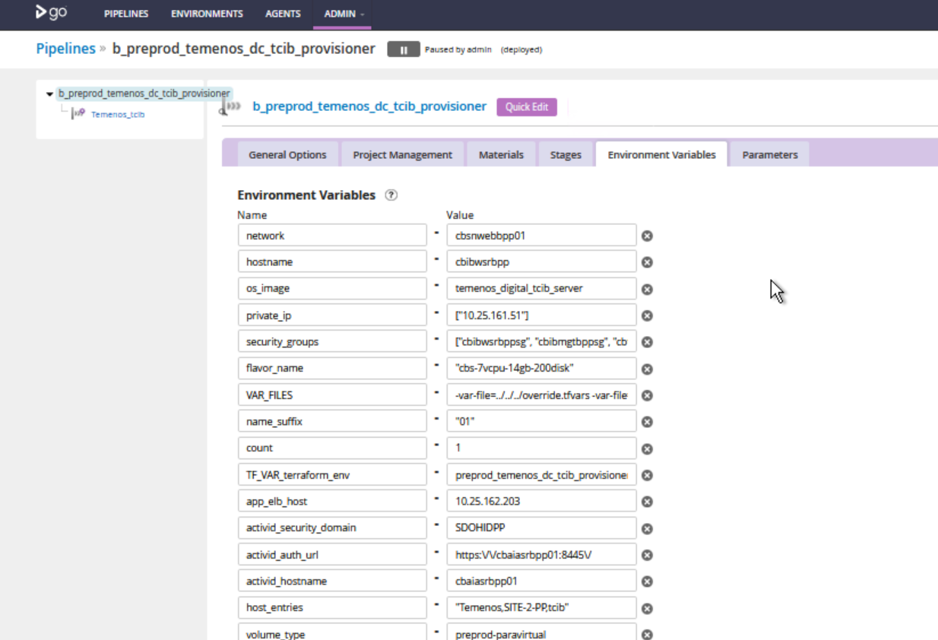

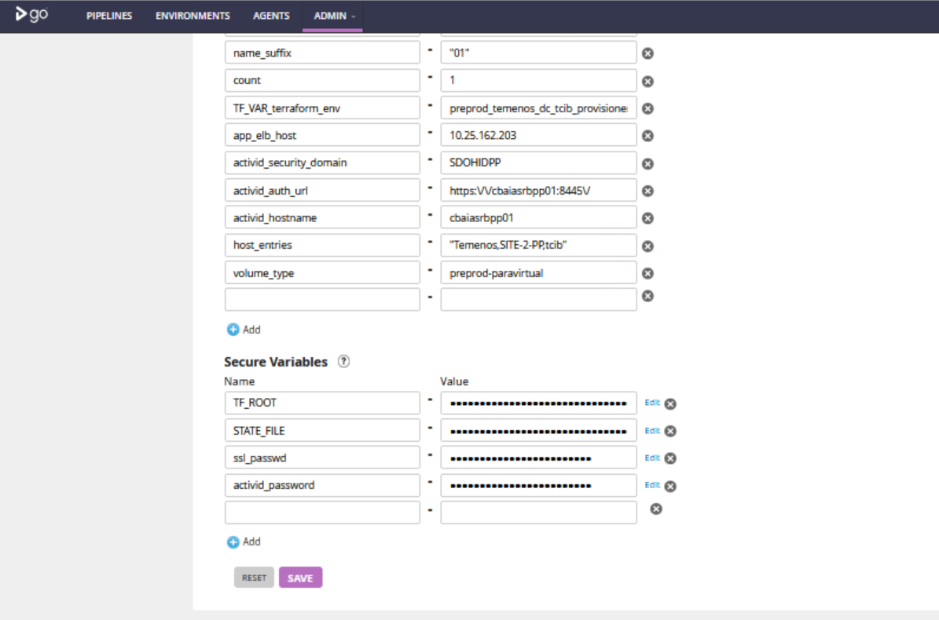

App\_elb\_host

Setting the elb host address in configuration file to communicate with app server

Activid\_security\_domain, Activid\_auth\_url, Activid\_hostname

Updating the value of Activid configuration in TCIB Server.

Ssl\_passwd,Activid\_passwd

Updating the ssl\_passwd in host-slave.xml

Updating the Passwd in Activid configuration files.

b\_preprod\_temenos\_hc\_tcib\_provisoner

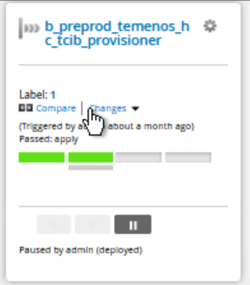

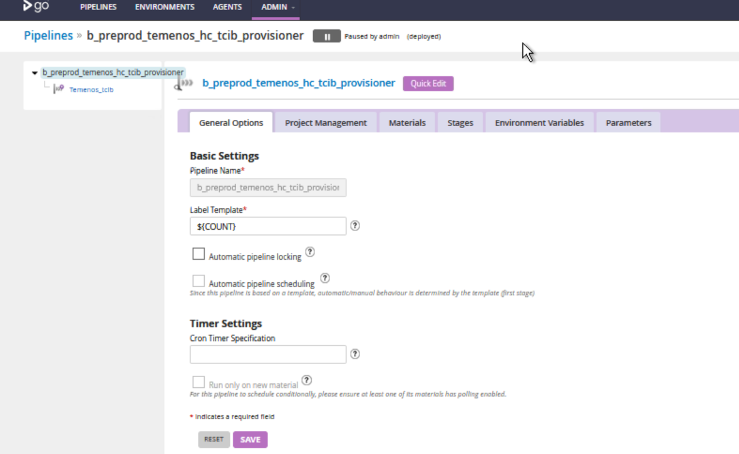

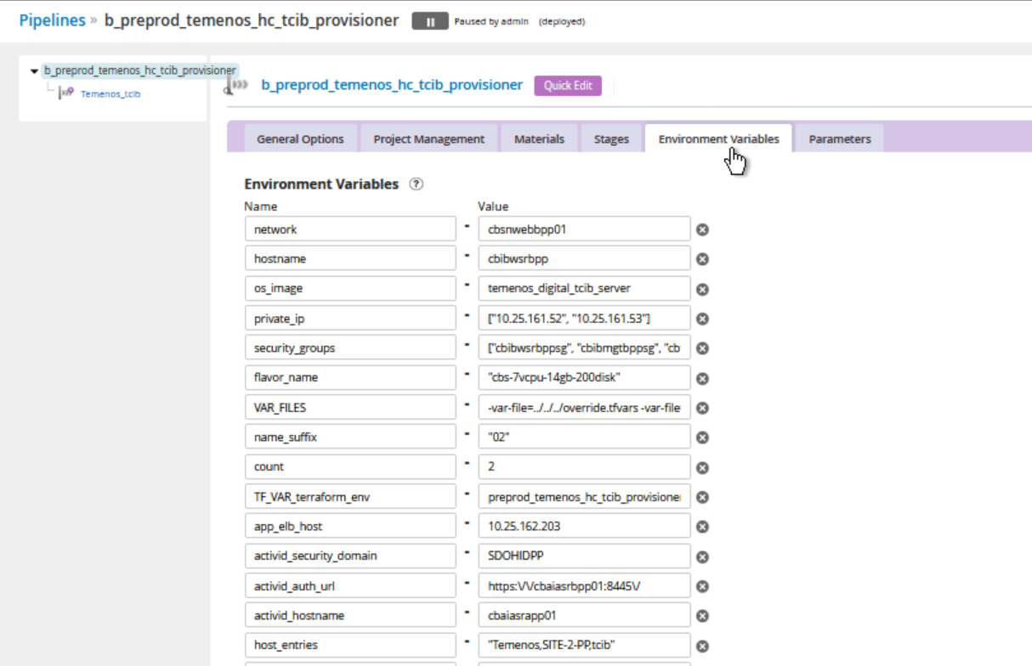

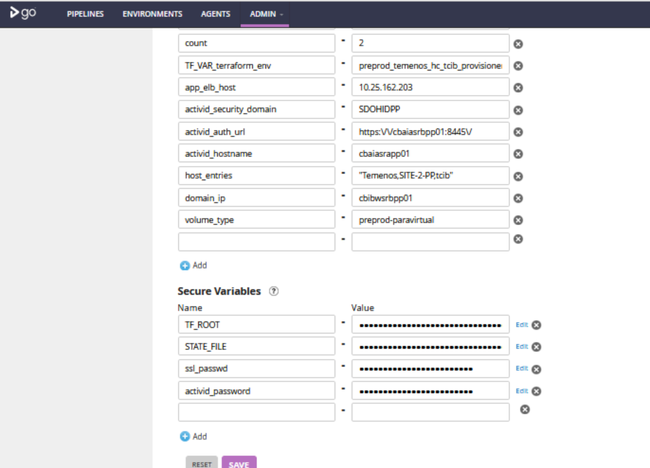

*App\_elb\_host*

Setting the elb host address in configuration file to communicate with app server

*Activid\_security\_domain, Activid\_auth\_url, Activid\_hostname*

Updating the value of Activid configuration in TCIB Server.

*Ssl\_passwd,Activid\_passwd*

Updating the ssl\_passwd in host-slave.xml

Updating the Passwd in Activid configuration files.

b\_preprod\_temenos\_dc\_browserweb\_provisoner

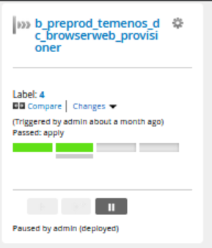

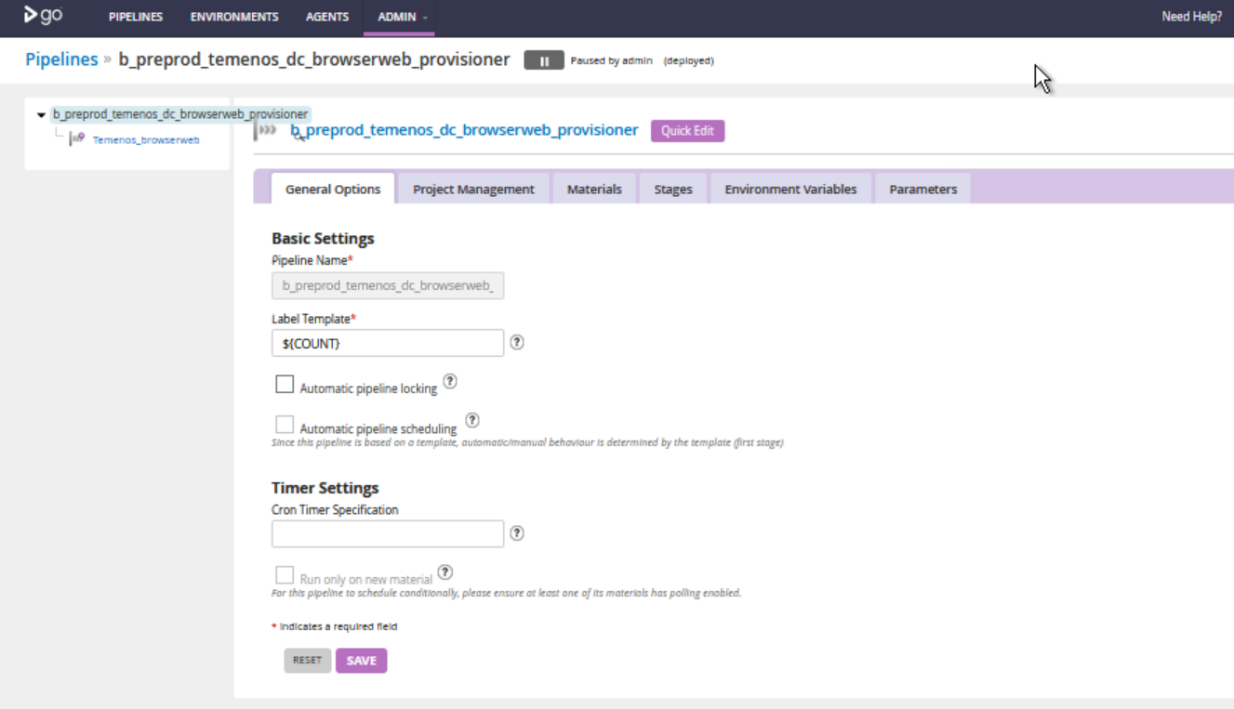

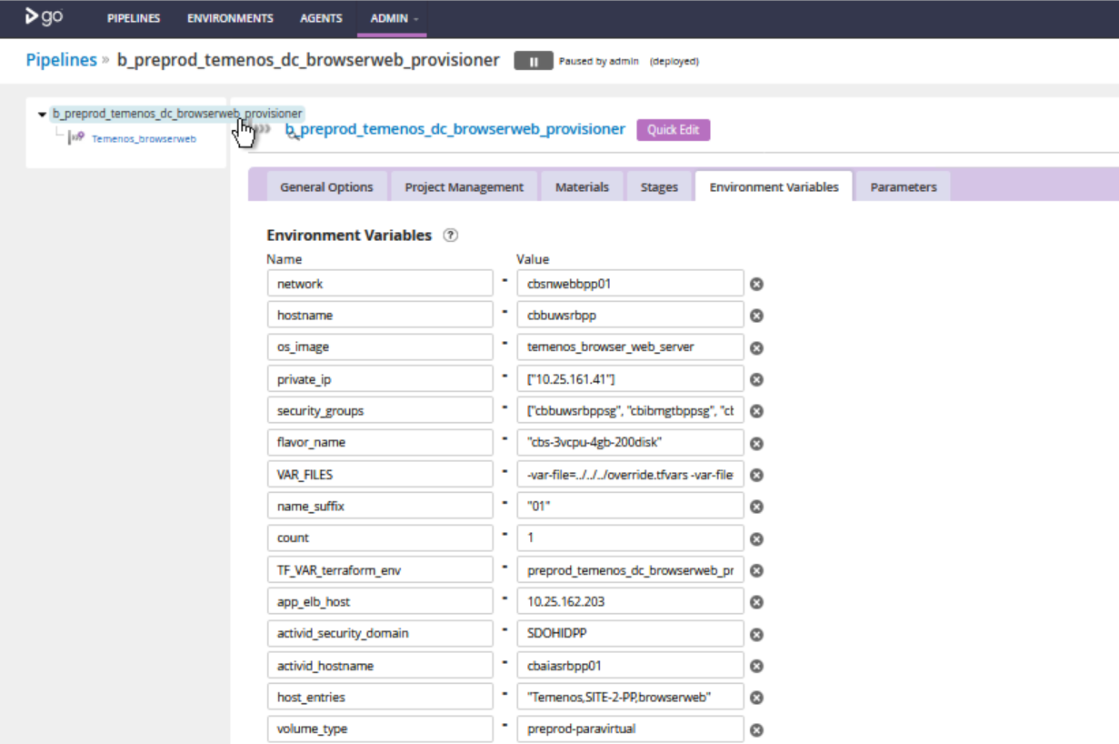

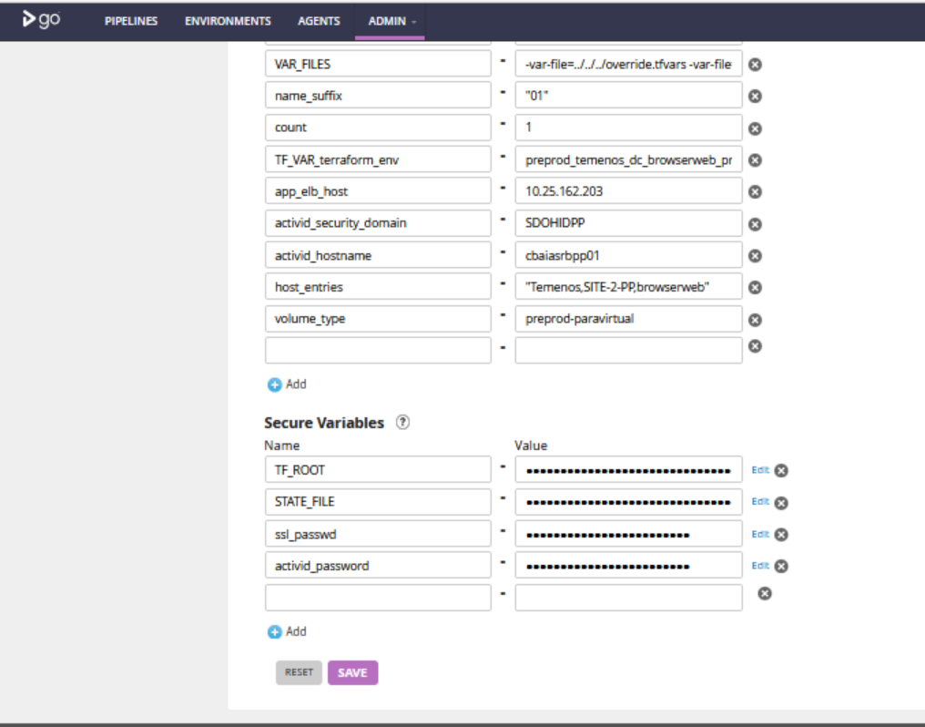

*App\_elb\_host*

Setting the elb host address in configuration file to communicate with app server

*Activid\_security\_domain, Activid\_auth\_url, Activid\_hostname*

Updating the value of Activid configuration in TCIB Server.

*Ssl\_passwd,Activid\_passwd*

Updating the ssl\_passwd in host-slave.xml

Updating the Passwd in Activid configuration files.

b\_preprod\_temenos\_hc\_browserweb\_provisioner

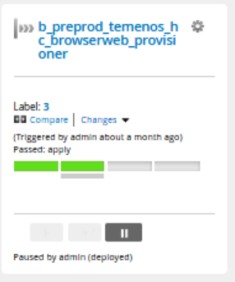

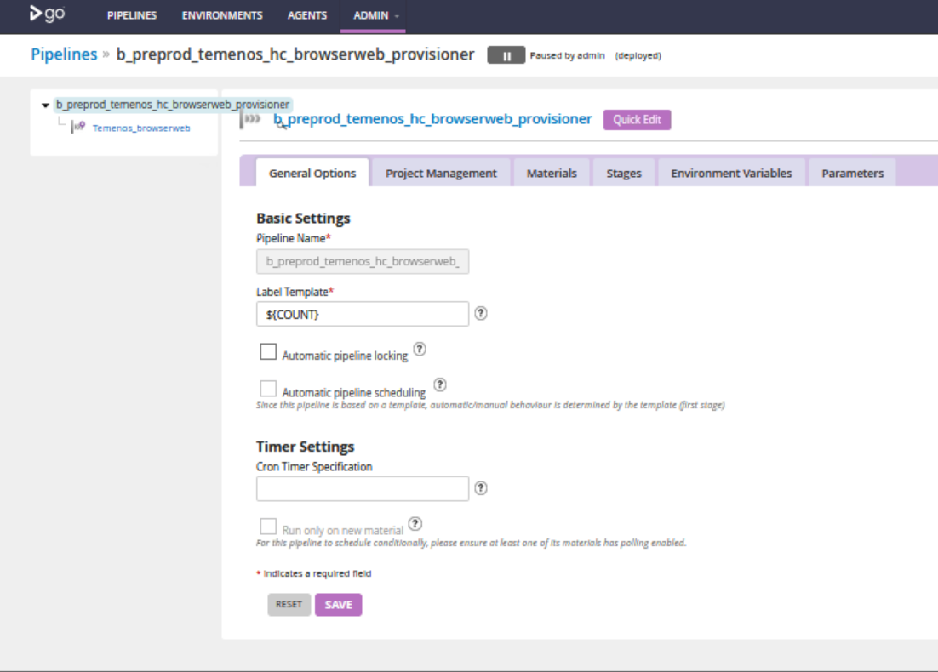

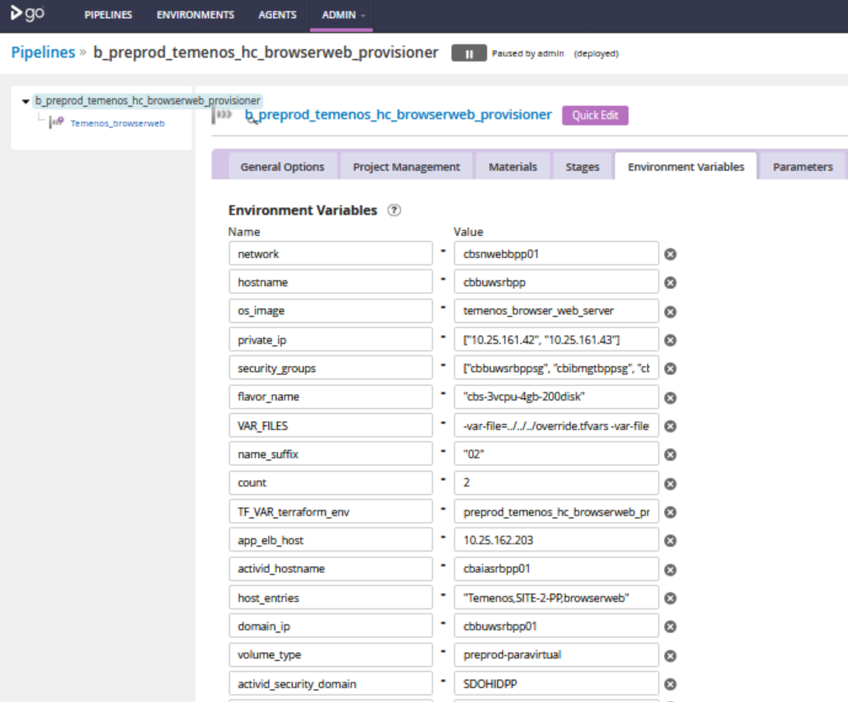



App\_elb\_host

Setting the elb host address in configuration file to communicate with app server

Activid\_security\_domain, Activid\_auth\_url, Activid\_hostname

Updating the value of Activid configuration in TCIB Server.

Ssl\_passwd,Activid\_passwd

Updating the ssl\_passwd in host-slave.xml

Updating the Passwd in Activid configuration files.

b\_prod\_temenos\_dc\_app\_provisioner

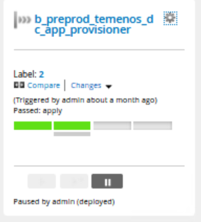

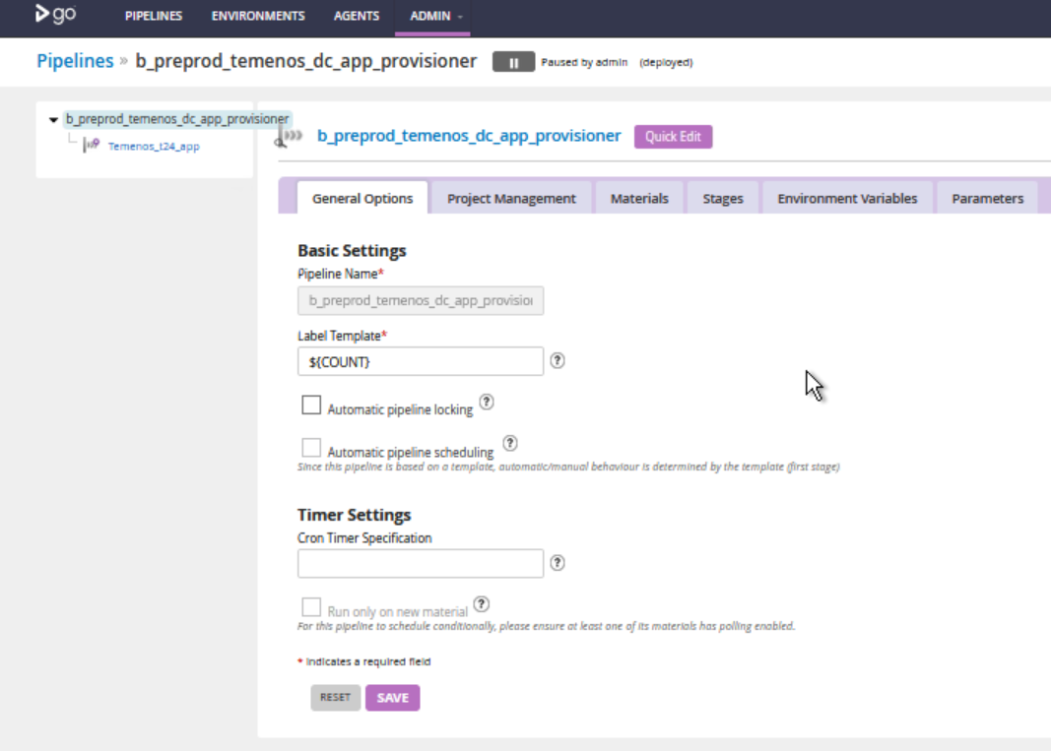

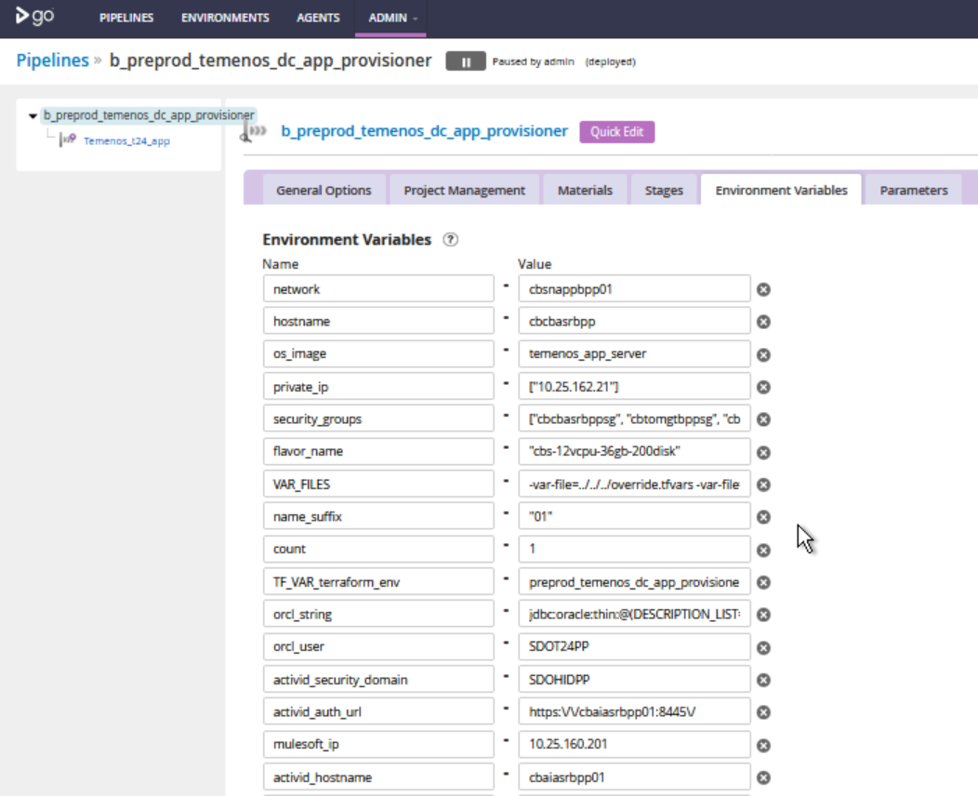

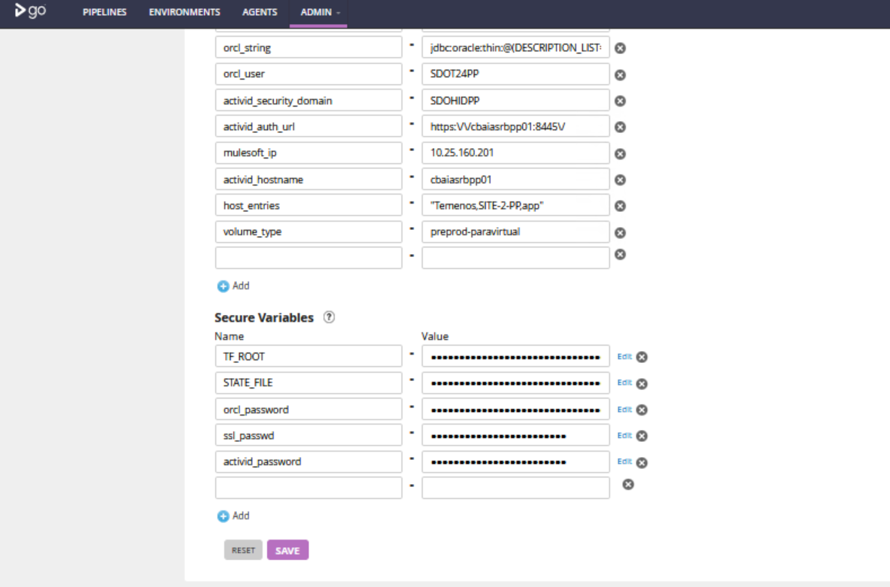

Orcl\_string

Updating the jdbc connectivity string in host-slave.xml

Orcl\_passwd and Orcl\_user

Updating the oracle username and passwd in host-slave.xml

Mulesoft\_ip

Ip of the mulesoft server

Activid\_security\_domain, Activid\_auth\_url, Activid\_hostname

Updating the value of Activid configuration in TCIB Server.

Ssl\_passwd,Activid\_passwd

Updating the ssl\_passwd in host-slave.xml

Updating the Passwd in Activid configuration files.

b\_prod\_temenos\_hc\_app\_provisioner

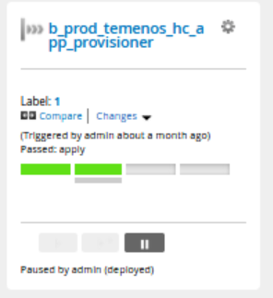

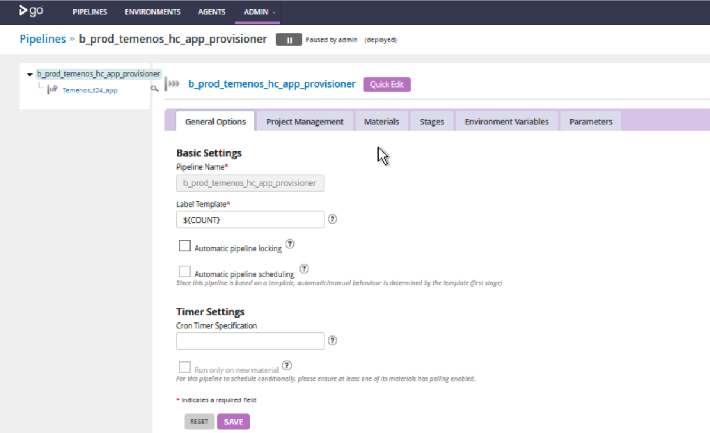

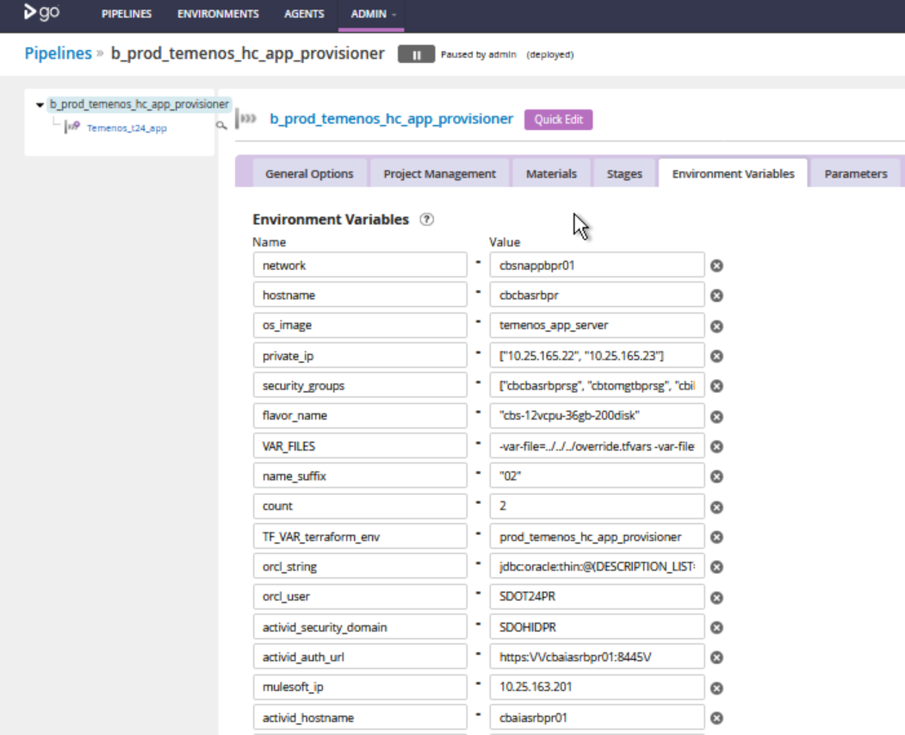

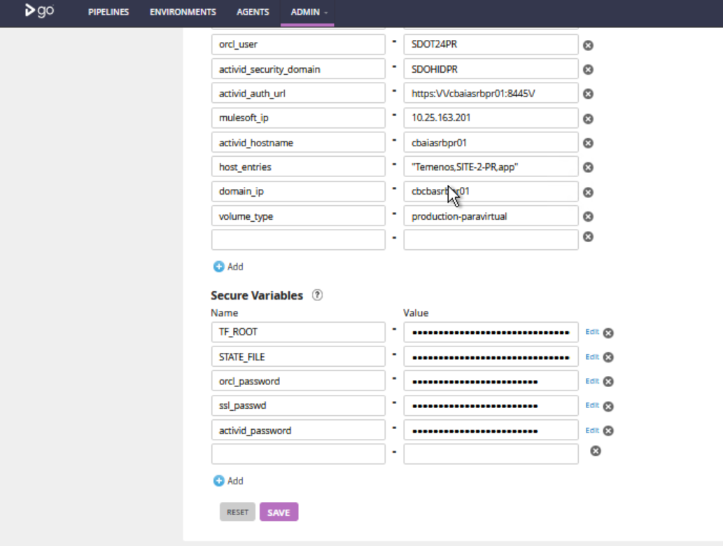

Orcl\_string

Updating the jdbc connectivity string in host-slave.xml

Orcl\_passwd and Orcl\_user

Updating the oracle username and passwd in host-slave.xml

Mulesoft\_ip

Ip of the mulesoft server

Activid\_security\_domain, Activid\_auth\_url, Activid\_hostname

Updating the value of Activid configuration in TCIB Server.

Ssl\_passwd, Activid\_passwd

Updating the ssl\_passwd in host-slave.xml

Updating the Passwd in Activid configuration files.

## General Information

Dev/Test vs Prod Environment

After Skysight we are maintaining all the Dev/Test environment in AWS. All the Prod and Preprod environment in VMware Integrated Openstack.

Server Configuration Dev/Test – AWS

Instance Type: m4.2xlarge

Server Configuration Prod/Preprod – OpenStack

|  |  |  |  |  |  |
| --- | --- | --- | --- | --- | --- |
| ROLE | OS | vCPU cores | Memory (GB) | Disk1 OS (GB) | Disk2 Data(GB) |
| TEMENOS\_APP\_SERVER | RHEL 7.2 | 12 | 36 | 200 | 300 |
| TEMENOS\_BROWSEWEB\_SERVER | RHEL 7.2 | 3 | 4 | 200 | 300 |
| TEMENOS\_TCIB\_SERVER | RHEL 7.2 | 7 | 14 | 200 | 300 |

Load Balancer Configuration Prod/Preprod

|  |  |  |  |
| --- | --- | --- | --- |
| SERVER | Port Type | Server Port | LoadBalancer Port |
| TEMENOS\_APP\_SERVER | HTTPS | 8443 | 8443 |
| HTTP | 8080 | 8080 |
| TCP | 5445 | 5445 |
| TEMENOS\_BROWSER\_WEB\_SERVER | HTTPS | 8443 | 8443 |
| HTTP | 8080 | 8080 |
| TEMENOS\_TCIB\_SERVER | HTTPS | 8443 | 8443 |
| HTTP | 8080 | 8080 |

# Document Control

|  |  |  |  |
| --- | --- | --- | --- |
| Version | Author | Date | Notes/Key Changes |
| 1.0.0 | Immediate | 4th | Initial draft |
|  |  |  |  |
|  |  |  |  |
|  |  |  |  |
|  |  |  |  |

About Capgemini

With more than 190,000 people, Capgemini is present in over 40 countries and celebrates its 50th Anniversary year in 2017. A global leader in consulting, technology and outsourcing services, the Group reported 2016 revenues of EUR 12.5 billion.

Together with its clients, Capgemini creates and delivers business, technology and digital solutions that fit their needs, enabling them to achieve innovation and competitiveness. A deeply multicultural organization, Capgemini has developed its own way of working, the Collaborative Business ExperienceTM , and draws on Rightshore® its worldwide delivery model.

Learn more about us at [www.capgemini.com](http://www.capgemini.com)

*Rightshore® is a trademark belonging to Capgemini*

|  |  |
| --- | --- |
| Locations_Map_2013.png | Name Name  Function  Function  Phone: 00 00 00 00 00  email@capgemini.com |
| Name Name  Function  Function  Phone: 00 00 00 00 00  email@capgemini.com |
| Name Name  Function  Function  Phone: 00 00 00 00 00  email@capgemini.com |
| Name Name  Function  Function  Phone: 00 00 00 00 00  email@capgemini.com |
| www.capgemini.com  Description: C:\Users\UserSim\Desktop\DS_icons\128x128 shadows\facebook.png Description: C:\Users\UserSim\Desktop\DS_icons\128x128 shadows\linkedin.png Description: C:\Users\UserSim\Desktop\DS_icons\128x128 shadows\twitter.png Description: C:\Users\UserSim\Desktop\DS_icons\128x128 shadows\youtube.pngPicto_Slideshare.gif  The information contained in this presentation is proprietary.  @ 2017 Capgemini. All Rights reserved. Rightshore is a trademark belonging to Capgemini. | |